After the image has been upscaled, it should be possible to downscale it to get back the original image. For a binary image, this could be accomplished by replacing each 3x3 pixel area with whatever value is the most common in it, or equivalently its median.

This means that a single pixel upscaled to 3x3 cannot be smoothed "too much". At least 5 pixels have to stay the same for the inverse transform to work.

This means that
XXX X
XXX -> XXX
XXX X

is valid, as are

XXX X
XXX XXX
XXX -> XXX
XXX XXX
XXX XXX
XXX XXX
::: :::

and

XXX X
XXX X
XXX -> XXX
XXX XXX
XXX XXX
XXX XXX
::: :::

I'm essentially constructing a very special smoothing/rounding filter.

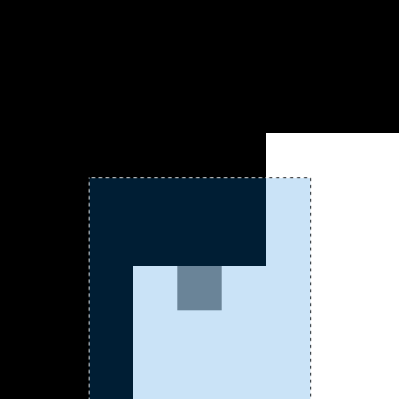
These two images have exactly the same 1x1, 3x3 and 5x5 statistics, but different desired
outcomes! They have different patterns however. Therefore I need to assign different pixels different values. Look-up table? Any symmetric arrangement of pixel values doesn't work actually.

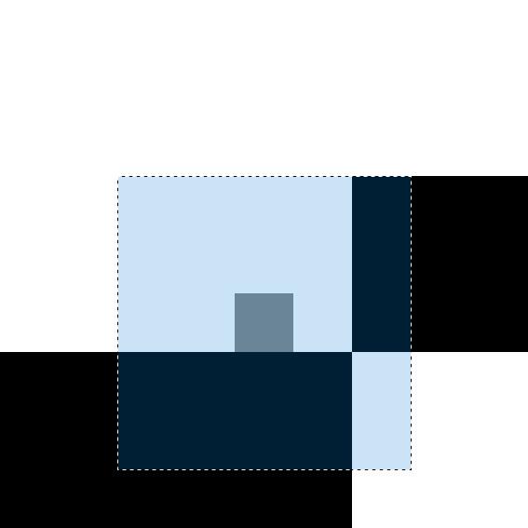
This could potentially be solved by using two applications of different filters, instead of one 5x5 filter.

Doesn't seem very easy...

What about using non-square median filters?
1x1, 1x3, 1x5, 3x3, 3x5, 5x5

2022-08-30
Going back, if we were using some kind of 3x3 median filter, then it would need to be able to recover the original image with the same method

If those two filter areas look statistically identical, then what about their derivatives?

00001 horiz 0001 00000
00001 and 0001 01110
01111 vert 1000 00000
01111 D's 1000 00000
01111 -> 1000

00001 horiz 0001 00000
00001 and 0001 1111-
11110 vert 000- 00000
11110 D's 000- 00000
11110 -> 000-

I've been looking at statistical averages this whole time. What about standard deviation or variance? Any variance measure will of course be the same, since the values of the data are the same.

It's not enough to look at pixel values, or locations. We need to look at correlations. Correlation matrix? 25x25?

How about we construct every possible scenario using a 5x5 filter and B&W pixels. We create that many look-up tables, together with the desired pixels. This solves the B&W problem. Then when moving to grayscale, we could look at which tables are closest to our situation, and potentially solve it from there.
How many look-up tables?
Three different kinds of pixels:
- Corner, sees 4 "mega-pixels". 16 different possible colorisations
- Edge, sees 6 mega-pixels. 64 different situations
- Center, sees 9 mega-pixels. 512 different situations
So in total 16+64+512=592 look-up tables
Many of these are rotations or mirror images of each other.

Instead of using lookup-tables, I should still try to make a neural net to learn the function. It would probably be a more useful exercise. How small can you make it? What pieces do you need?

I should try making the image patches into individual data instances, and then doing SGD instead of GD.

I'm calculating the correlation wrong!? A kernel with larger values will give a bigger correlation. I need to normalize the product, or to set image values to interval [-0.5, 0.5]?

Need to calculate Pearson correlation coefficient? Ratio of covariance to the product of standard deviations.

I would like to just multiply the values, and divide by the product of their norms. I wonder if this would work.

I can calculate the covariance as cov(x,y) = E[(x-E[x])(y-E[y])], or as E[xy] - E[x]E[y]. However this is numerically unstable. How to make it stable? If using a CNN, where I have parallelism and thus speed, and my data is x and my filters are y, then I have available the products xy, xE[y] (maybe), E[x]y, (x-E[x])y. No, I don't have easy access to E[x], because x is 5x5 batches of the image. I can convolve the image with an averaging filter though.

Correlation coefficient (normalized covariance) can be calculated as \ro_{x,y} = cov(x,y)/(std(x)std(y))

Should I try a fully-connected network after all?

Don't use a neural net, just go through the training image, and save all the image patches found, and the desired results. Much easier.

2022-09-23
It is not possible to have moderate rounding of line ends with 5x5 lookup-tables:
11111 11111
00011 00111
00011 -> 00011
00011 00111
11111 11111
If I want that, then I need to use 7x7 tables. Otherwise they get sharpened a lot.

2022-09-24
The training image I'm using doesn't seem to have all of the necessary cases. I have a few alternatives.
- Generate an image with all possible pixel configurations, and train on that.
- Make some rules that would cover many of the cases, and cover the rest with training.
- Train with more hand-crafted images.

2022-09-25
Demands for the smoothing algorithm:
- When downsampled by taking a median of each 3x3 area, should return the original image?
- The average brightness of the image should not go up or down when smoothed

This solution does not handle the ends of lines as I want. I would need to use a 7x7 kernel. How many 3x3 pixels can a 7x7 filter see? Is that 3x3 also? So I could use the existing De Bruijn sheet? Confirmed, 7x7 filter always sees a 3x3 megapixel area!

Alright, I have the B&W situation working. Now I need to calculate correlations between tables. I can find the table that is the closest to the current image patch, but then how to decide what I need?
Let's imagine that we have a situation that is close to a binary situation, like an area between two black megapixels needing a black pixel. An area between two dark megapixels needs a dark pixel. I would like to use only pre-existing colors, so I need to pick one of the darker colors in the 3x3 megapixel area. Should I pick the darkest one?

The most basic rule is to pick the most abundant pixel, or the median pixel.

2022-10-01
Treat the binary lookup tables as masks! The lookup table value tells you which part of the image patch to look for target value. Take the median of that area of the patch?

I need to cluster the values based on contrast?

2022-10-19
I need to compose grayscale values using the B/W lookup tables. I can use the areas from which the target values is picked from.
Two possible solutions:

Sometimes, like in the case of the tip of the heart, there are two lookup tables that correspond well to the pattern. The one with a black, filled heart, and one with a hollow heart. Overlapping the areas with the target value, we get the interior of the heart, which is exactly the grayscale value that we want.

The example grayscale image has three different values, meaning that it can presented as a combination of the two BW patches. Is this a solution?

2022-10-23
Two main ideas:
- Closest lookup tables with overlapping masks
- Lookup table decomposition (might require a greedy algorithm?)
- With final value proportional to the tables used
- With final value looked up from the cross-section of the tables used

2022-12-02
Solve the 3x3 filter case first! Make a De Brujin sheet with all 2x2 binary combinations, and solve the simpler median processing case for grayscale images! Then can move on to the 7x7 case.

2023-02-26
Possible solution:
- Scale impatch to 0-1
- Find the closest lookup table
- Take the median or mode in the area corresponding to the new value of the closest lookup table
Median doesn't work. Mode maybe? But in any case just looking at the closest lookup table fails to capture some of the nuance I think...

2023-03-05
This is really an interpolation problem. The LUT's are a mapping from matrix (or vector) 0,1,1,1,1,0,0,1,0 to {0,1}, and moving to grayscale means mapping inputs x where we don't know the correct output y.

Note that every binary function also defines a two-tone function from a,b,b,b,b,a,a,b,a to {a,b}, for each 0<=a<b<=1 We might need a function that maps an image patch to the closest scaled lookup table.

Once we have these function mappings, we need to interpolate the grayscale image patches with those. The most obvious way to do it is nearest neighbour, or k-NN.

2023-03-07
I need to find the closest two-value approximation to a given image patch

2023-03-14
I’m getting excellent results with the ImageResizerInterp. Only some details are erranous, but the lines seem great! But how did I do it? I seem to be using the 2x2 De Brujin sheet…

Okay I’m getting good results with the right Brujin sheet also. The interpolation method is working well. The main problem now seems to be the LUT matching. For example the LUT closest in shape to
.6 .6 .6 .6 .6 .3 .3
.6 .6 .6 .6 .6 .3 .3
.6 .6 .4 .4 .4 .1 .1
.6 .6 .4 .4 .4 .1 .1
.6 .6 .4 .4 .4 .1 .1
.4 .4 .6 .6 .6 .6 .6
.4 .4 .6 .6 .6 .6 .6

would in my mind be

1 1 1 1 1 0 0
1 1 1 1 1 0 0
1 1 0 0 0 0 0
1 1 0 0 0 0 0
1 1 0 0 0 0 0
0 0 1 1 1 1 1
0 0 1 1 1 1 1

but is

1 1 1 1 1 0 0
1 1 1 1 1 0 0
1 1 1 1 1 0 0
1 1 1 1 1 0 0
1 1 1 1 1 0 0
1 1 1 1 1 1 1
1 1 1 1 1 1 1

closer?

If we let the LUT be scaled and shifted arbitrarily, so that it will have values a and b instead of 0 and 1, then assigning a = 0.6 and b=0.4 is indeed the closest, I believe.

Instead of scaling the image patch, I could scale the LUT. Although these might be interchangeable.

Is the correct scaling algorithm to set a to be the most populous value, and b to be the second-most populous value, and the rest of the values to a or b, depending on which is closer?

We can think of this in 1D. What if the values are .01 .02 .03 .04 .05 .98 .98 .99 .99? Clearly the closest LUT is .03 .03 .03 .03 .03 .98 .98 .98 .98 (or the last four can be .99), and not .98 .98 .98 .98 .98 .98 .98 .99 .99

Dammit I think I need a quantization algorithm with two output values that best represent the image patch values in an L1 sense. Also the output values need to be present among the original input values.

I can think of each LUT as an a,b-valued LUT, where 0<a<b<1.

Median is a kind of quantization algorithm? All represented by one value. It is not the value that minimizes the L1 loss though… Isn’t that the mean? No, I think mean minimizes the L2 loss. It is the median! So I need a version of median that has two outputs, not one.

Example data
1,1,1,97

L1 error with mean
25,25,25,25
24+24+24+73 = 145

L1 error with median
1,1,1,1
0+0+0+96 = 96

I could potentially try using the L2 loss to find the closest LUT… This gets into clustering too…

2023-03-19
I’m tempted to just order the data, take the 25th and 75th quantiles as cluster centers, then divide the data into two clusters based on which center is closer.

2023-03-23
Just brute force the clusters! There are only a maximum of nine groups of pixels, so max. 9 different pixel values, and two clusters!

2023-04-01
I’m finding the correct lookuptables and thus masks, but how do I get the correct values from the masks? Something like median doesn’t work. Sometimes the central pixel value changes, and this is unacceptable.

How about, IF the pixel value is to change (the central pixel’s value is not included in the mask), THEN we look at the mask values, and otherwise we simply keep the existing pixel value.

That didn’t work. Uhh… Pick one of the cluster centers to be the new value.

Okay I’m running out of ideas. Try the algo on the binary Rhydons, to see if at least those are correct.

Combine the original picture, biased median and the LUT approach

What if we treat different parts of the 3x3 pixels differently? Center, edge, corner
Add together all the patterns where we want a 1, and subtract from that all the patterns for which we want a 0. That should show us which pixels are relatively most/least important for each value. Analysis! Didn’t help much, just shows the importance of close/far away pixels.

Adding together just the values for 0 should show the most important pixels for those?

List the amounts of black and white pixels for each pattern, and their desired result. Only for edge pixels! See if there is a simple pattern, or if it can be defined only by the amounts of values. Make sure the De Brujin graph is drawn correctly! Unfortunately there seems to be a massive amount of overlap.

Using a median filter on resized Rhydon with a bias of 1 does a crazy thing. It shrinks all lines to thickness of 1, so that the nature of the drawing changes.

Clustering and interpolation method actually works now??? The results are like 99% perfect, with median, mode and mean all producing almost identical results. Median still the best probably.

Using the method simply on each channel of a color image doesn’t always work. Fix? What we need to do is to cluster the 3D points into two different clusters. But how do we decide which one is the “lower”, and which one the “higher” cluster? Brightness? What if we have red and blue colors of equal brightness? Choose some color at random? Color images can still be biased towards having a white background and black lines. But in terms of color… Maybe blue-yellow axis, since blue is the darkest and yellow is the brightest.

2023-05-19
A pixel in the center of a 3x3 area of identical pixels should surely never change.? Does this ever happen?

Next fix the RGB version of the LUT usage case

Find the best clusters for the RGB values, and divide the pixels into them. Then use LUTs based on the locations. Currently the grayscale and RGB algorithms don’t give the same results for Rhydon, for example

2023-10-28
The biased median filtering doesn’t seem to work (the corner cases). Fix using Rhydon picture.

Because I’m not using a biased median, but a biased mean(oid)! Need to check which pixel value in the 3x3 area (except center, replace with (0,0,0)) has the smallest average L1 distance. So what is the medoid of the pixel group? “Biased medoid”

2023-11-01
Add image resizing as part of the code

Also add edge processing. Interpolate the image beyond the edges, process it and crop it.

Make the whole thing a function with variables you can input

In the end make it so you can choose between the amount of depixelization you want for both grayscale and RGB images.

2023-11-02
Make the (biased) medoid finding its own method so you can use it in the corner and edge cases. Also improves readability

In Github, showcase test image 2, Rhydon, Beautifly and Venusaur

2023-11-05
Messing with the De Bruijn graph could give better results

